Simple Genetics Quiz

Name:

1. For each genotype, indicate whether it is heterozygous (HE) or homozygous (HO)

|  |  |  |  |
| --- | --- | --- | --- |
| AA HO | Ee HE | Ii HE | Mm HE |
| Bb He | ff HO | Jj HE | nn HO |
| Cc He | GG HO | kk HO | OO HO |
| Dd He | HH HO | Ll HE | Pp HE |

1. For each of the genotypes below, determine the phenotype.

*Purple flowers are dominant to white.* PP purple Pp purple pp White

*Brown eyes are dominant to blue eyes*. BB Brown Bb Brown bb Brown

*Round seeds are dominant to wrinkled.* RR Round Rr Round rr wrinkled

*Bobtails are recessive (long tails dominant)*. TT Long tails

Tt Long tails

tt Bobtails

1. For each phenotype, list the genotypes. (Remember to use the letter of the dominant trait)

*Straight hair is dominant to curly. Tail spikes are dominant to plain tails.*

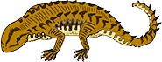 SS straight PP pointed

Ss straight Pp pointed

ss curly pp round

1. Set up the square for each of the crosses listed below. The trait being studied is round seeds (dominant) and wrinkled seeds (recessive)

r

r

# Rr x rr

rr

rr

Rr

Rr

r

R

What percentage of the offspring will be round? 50%

# Rr x R r

R

Rr

RR

r

rr

Rr

r

R

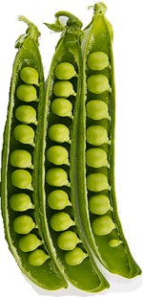What percentage of the offspring will be round? 75

r

R

# RR x Rr



Rr

RR

Rr

RR

R

R

What percentage of the offspring will be round? 100

## Practice with Crosses. Show all work!

1. A TT (tall) plant is crossed with a tt (short plant).

What percentage of the offspring will be tall? 100

1. A Tt plant is crossed with a Tt plant.

What percentage of the offspring will be short? 25

1. A heterozygous round seeded plant (Rr) is crossed with a homozygous round seeded plant (RR).

What percentage of the offspring will be homozygous (RR)? 50

1. A homozygous round seeded plant is crossed with a homozygous wrinkled seeded plant.

What are the genotypes of the parents? RR x rr

What percentage of the offspring will also be homozygous? 0 What is the genotype of all of the offspring? Rr

1. In pea plants purple flowers are dominant to white flowers.

If two white flowered plants are cross, what percentage of their offspring will be white flowered? 100

1. A white flowered plant is crossed with a plant that is heterozygous for the trait.

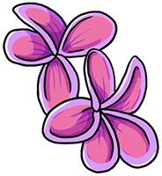What percentage of the offspring will have purple flowers? 50

1. Two plants, both heterozygous for the gene that controls flower color are crossed.

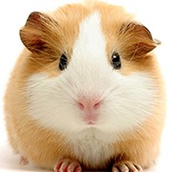What percentage of their offspring will have purple flowers? What percentage will have white flowers?

75

25

1. In guinea pigs, the **allele for short hair is dominant.**

What genotype would a heterozygous short haired guinea pig have? Rr

What genotype would a purebreeding short haired guinea pig have? RR

What genotype would a long haired guinea pig have? rr

## Show the cross for two heterozygous guinea pigs.

What percentage of the offspring will have short hair? 75

What percentage of the offspring will have long hair? 25

